CS 255 System Design Document Template

UML Diagrams

UML Use Case Diagram
The use case diagram shows how customers, secretaries, driver/trainers, the owner, the IT officer, and the DMV system interact with DriverPass. It includes scheduling appointments, taking practice tests, managing accounts, and viewing reports.

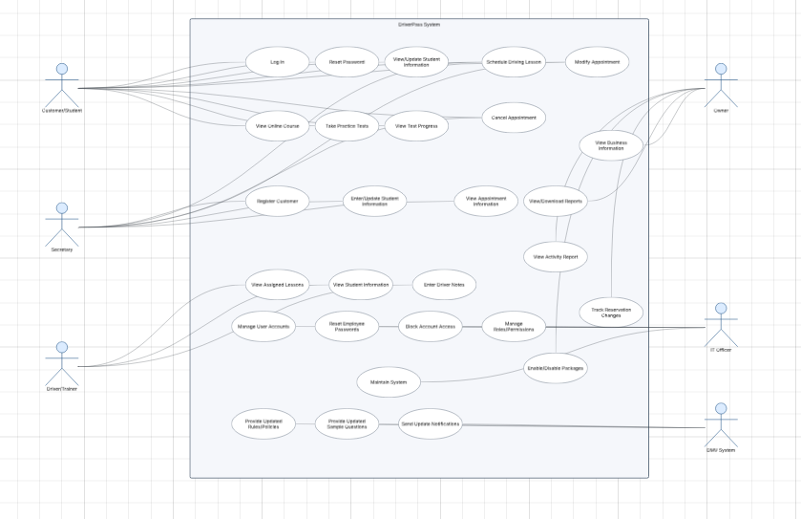

UML Activity Diagrams

Schedule Driving Lesson
This activity diagram shows how a customer selects a date and time, checks availability, and either confirms an appointment or chooses another time.

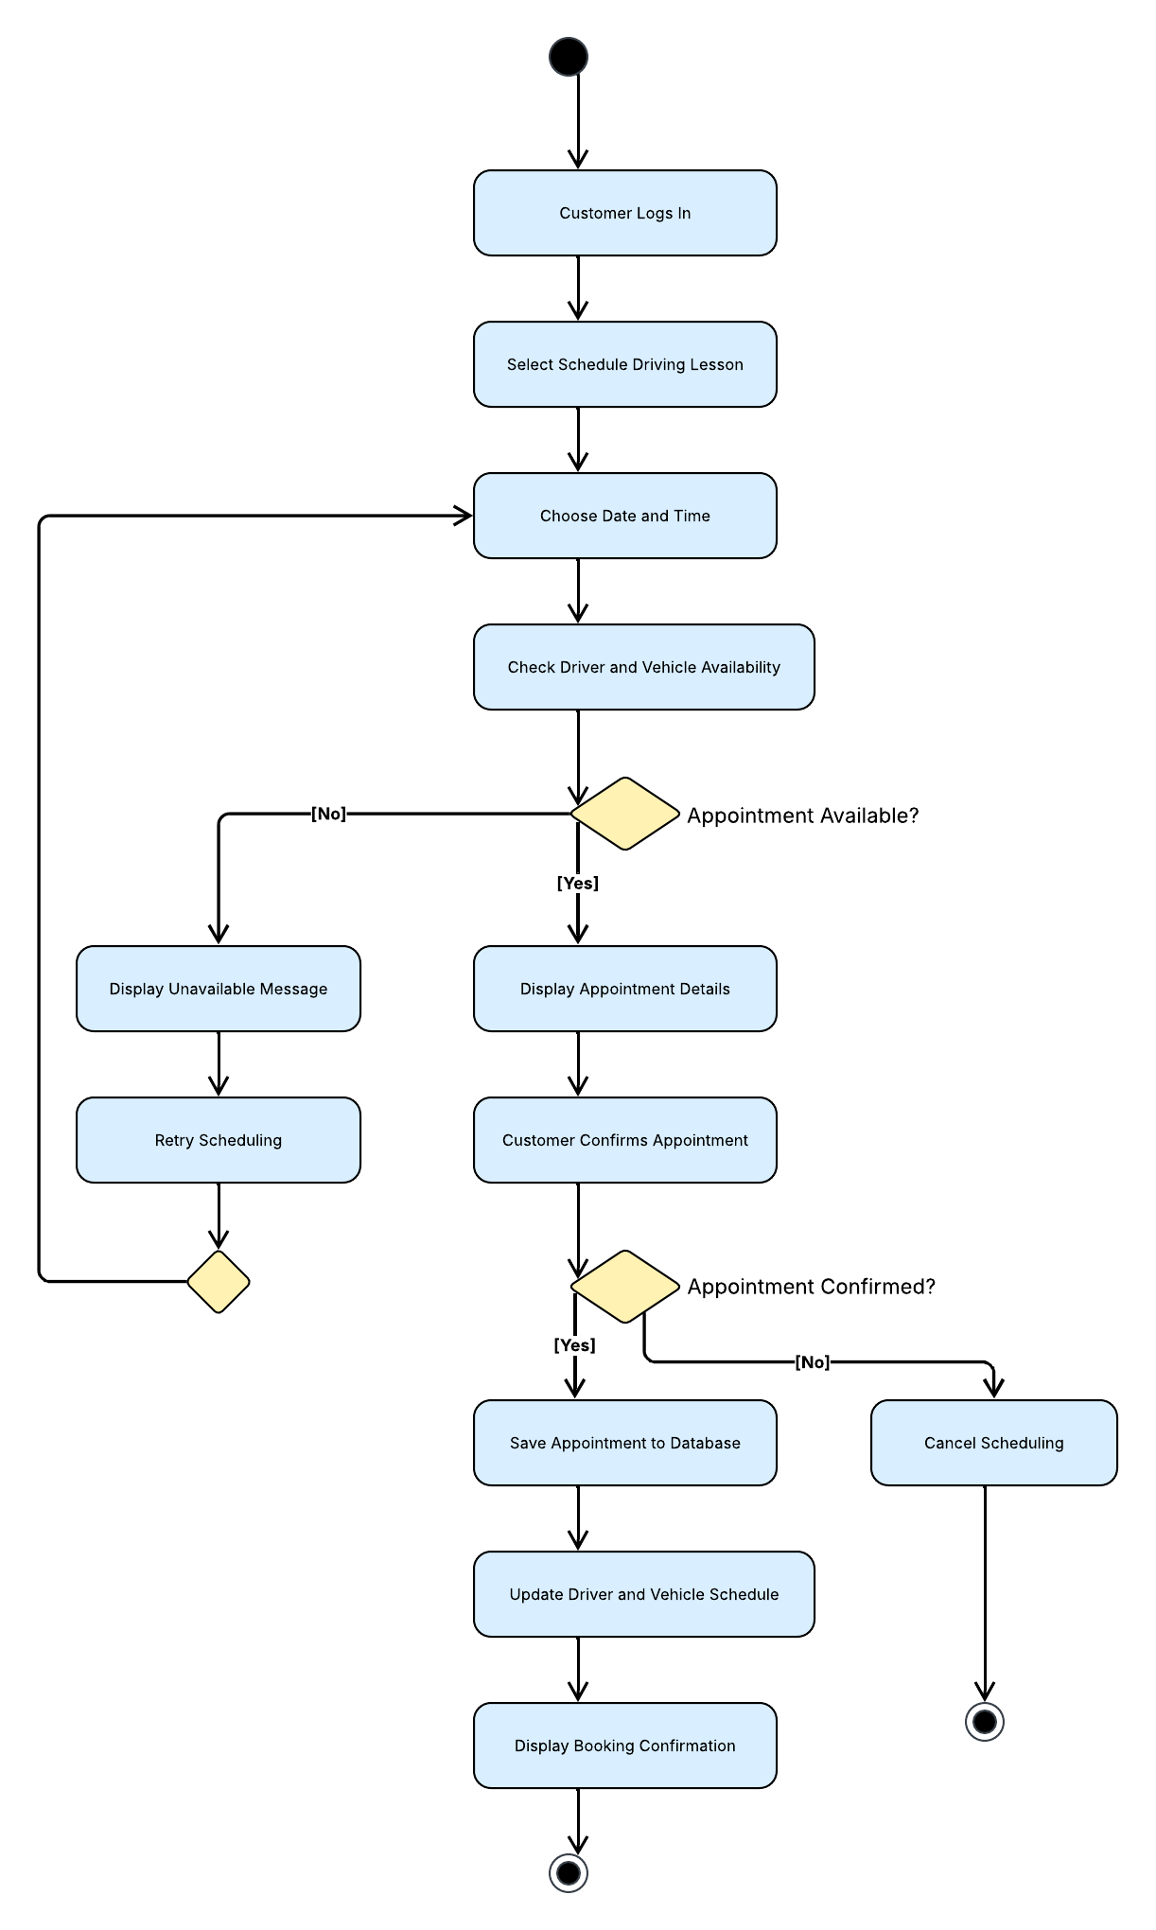

Take Practice Test
This activity diagram shows how a customer answers questions, submits the test, and receives a score that is saved to their account.
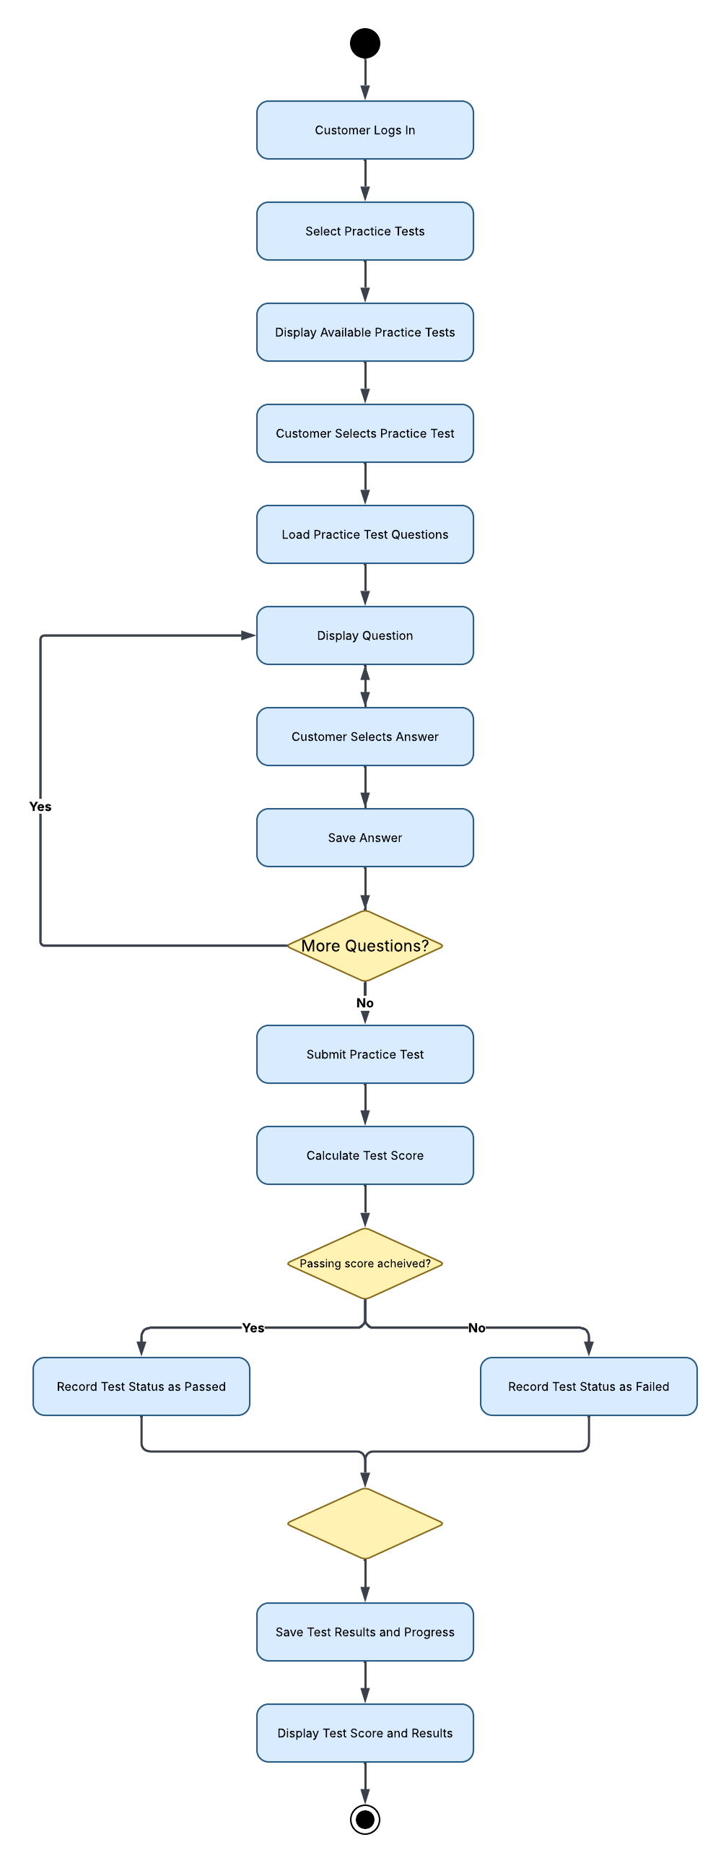

UML Sequence Diagram

The sequence diagram shows the messages exchanged between the customer, DriverPass website, scheduling system, driver/vehicle database, and appointment database during lesson scheduling.

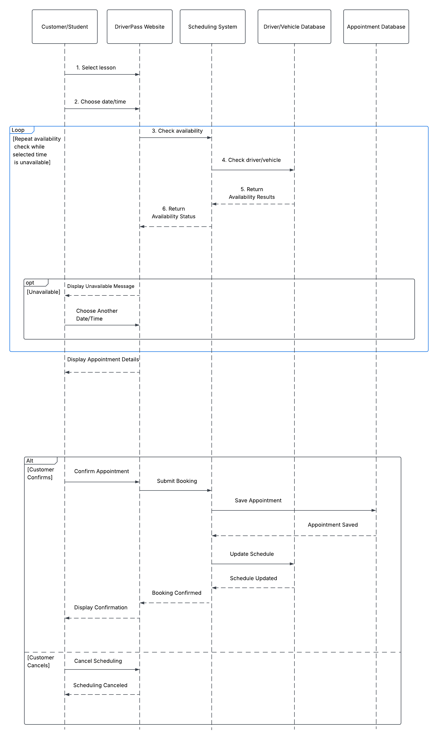

UML Class Diagram

The class diagram identifies the main information DriverPass needs to store, including users, customers, employees, driver/trainers, appointments, vehicles, training packages, practice tests, and test results. It also shows how these records relate to each other.

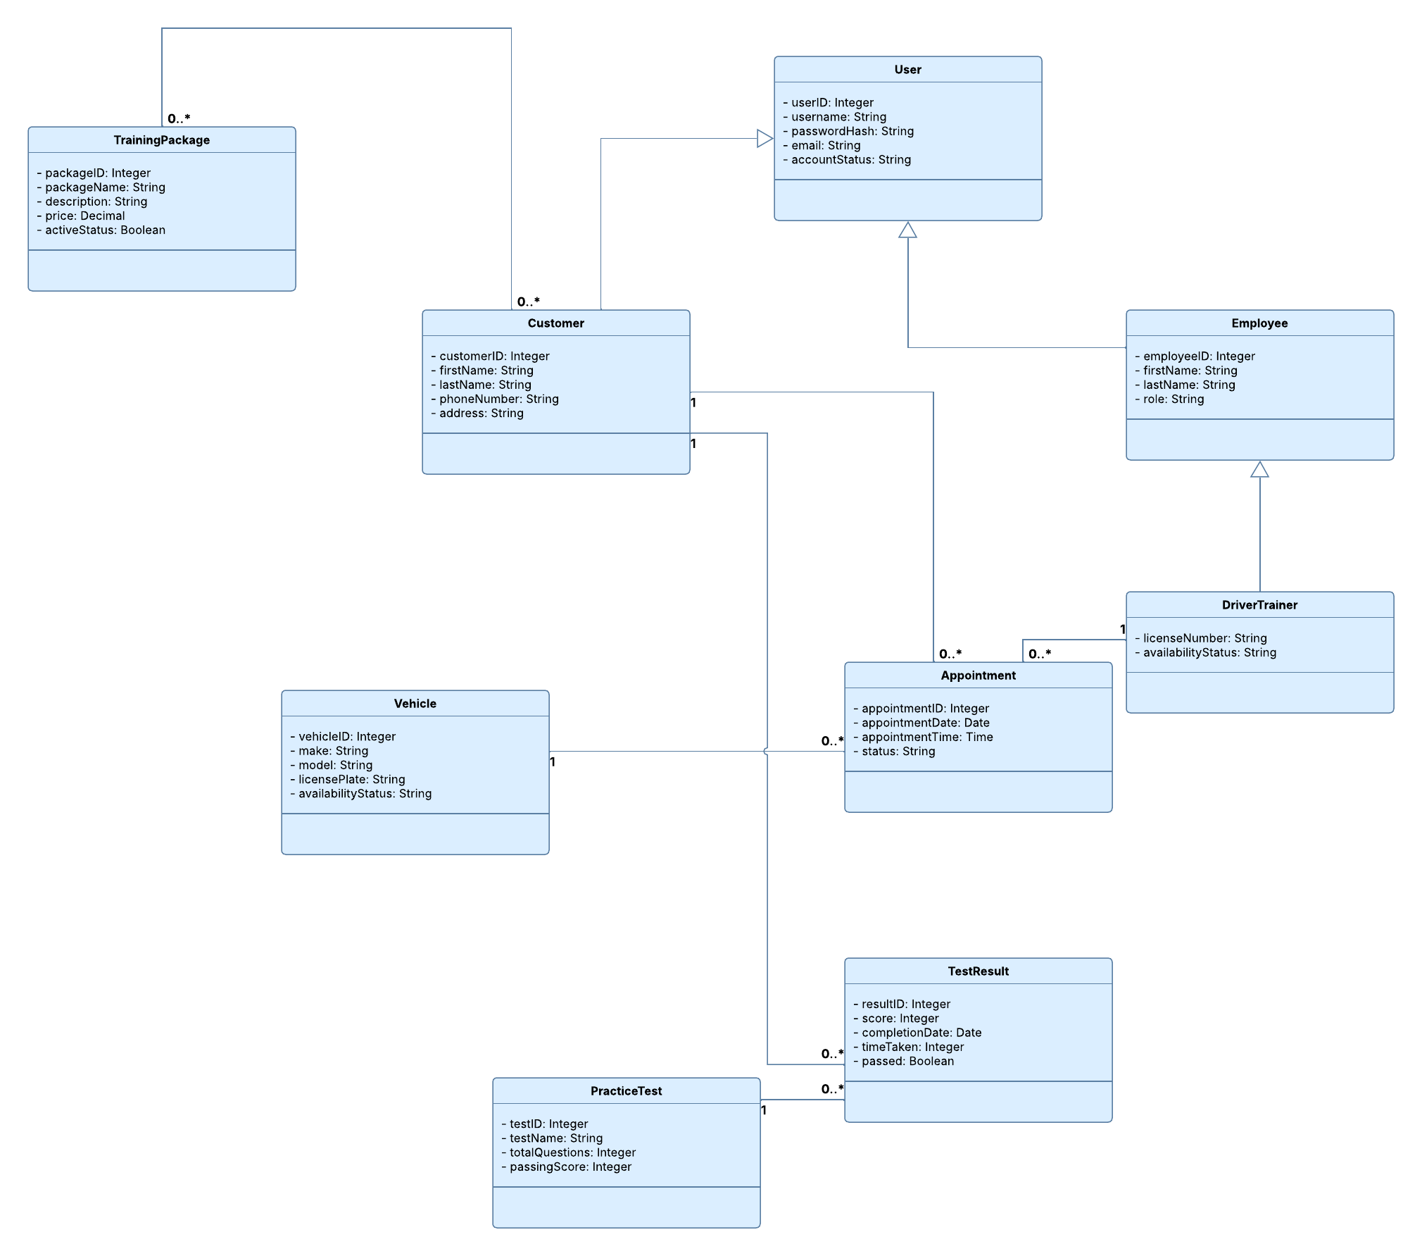

Technical Requirements

Hardware:
DriverPass should use a cloud-hosted server instead of maintaining its own physical server. Customers will need a computer, tablet, or smartphone with internet access. Employees will need office computers with reliable internet access, and a printer will be useful for reports and appointment records.

Software:
The system will be a web-based application that works through common browsers without requiring customers to install additional software. It will need software for account management, scheduling, online courses, practice tests, and reporting. A relational database will store customer information, appointments, driver and vehicle schedules, training packages, and test results. The application should check availability before saving appointments and update schedules immediately when a booking is made, changed, or canceled.

Tools:
Developers will need programming and database management tools to build and maintain the website and its records. Lucidchart will be used for the system's UML design diagrams. Testing tools will also be needed to check login security, scheduling conflicts, practice test scoring, and compatibility with different browsers and devices. Administrators should have tools to manage accounts, change permissions, review activity reports, and update training materials when DMV information changes.

Infrastructure and Security:
Cloud hosting should provide the website, application services, database storage, backups, and room to support multiple users at once. DriverPass will need a secure internet connection using HTTPS to protect information sent between users and the system. Passwords should be securely hashed, and role-based permissions should limit what customers, employees, trainers, and administrators can access. The system should support password resets, temporary account restrictions after repeated failed logins, and records of appointment changes. Backups and recovery procedures are needed to reduce the risk of losing customers and scheduling information. These technical choices support DriverPass's goal of making driver training easier to access while keeping customer records, scheduling, and training progress organized in one system.

